Template for preparing a research article for submission to *Optica (title of experiment)*

**PHYC 476/477/302L**

**Lab Report**





**Research Article**

Author One,1 Author Two,1 Author Three,2,*

1Univerity of New Mexico, Optical Science and Engineering (OSE), PhD Program

2Univerity of New Mexico, Physics and Astronomy, Undergraduate Program

*Corresponding author: [author_three@unm.edu](mailto:author_three@unm.edu)

Experiments Conducted during *date* to *date,* Report Submission Date: *date*

ABSTRACT (<100 words) : This template can be used to prepare a research article for submission to OSA’s new journal, *Optica*. Consult the [OSA Author Style Guide](http://www.opticsinfobase.org/submit/style/jrnls_style.cfm) for general information about manuscript preparation. © 2014 Optical Society of America

**OCIS codes:** (140.3490) Lasers, distributed-feedback; (060.2420) Fibers, polarization-maintaining; (060.3735) Fiber Bragg gratings; (060.2370) Fiber optics sensors.

http://dx.doi.org/10.1364/optica.99.099999

To use this template, you will need to apply the embedded styles to each paragraph-level item in your manuscript, or simply use this template as a visual guide. REPORT PAGE LIMIT: 4 Pages

**Headings.** The styles for the three levels of headings in *Optica* are

1. SECTION

**Use SECTIONS for “INTRODUCTION”, “EXPERIEMNTAL SET-UP”, “DATA”, “ANALYSIS”, and “COCNCLUSIONS”**

A. Subsection 1

1. Subsection 2

**Using the Word styles.** In this template, styles such as “01 Title” for the manuscript appear in the MS Word Styles ribbon (or toolbar for older versions of Word). Apply the appropriate style before typing or apply the style to existing text. It is possible to paste manuscript text into this template or attach this template to an existing manuscript.

**Equations.** Display equations should be broken and aligned for two-column display unless spanning across two columns is essential. For MathType math, use the Format Equations feature to format all equations as Times + Symbol 10. Apply the Equations style to create appropriate spacing above and below.

 (1)

**Tables.** Styles for table title, table head, and table text are provided in the MS Word Styles ribbon. Tables should be set as one column wide if possible and be placed near their first mention in the body.

**Figures.** As with tables and equations, figures should be set as one column wide if possible unless two-column display is essential. If possible, set the figures in the desired position within the text.

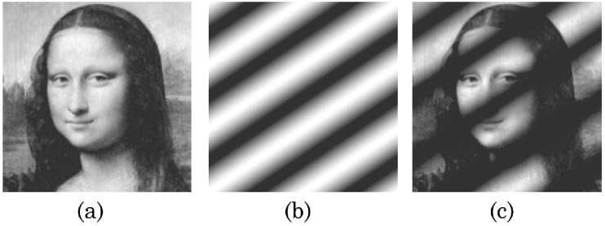Fig. 1. Caption text. From Gill *et al.,* Opt. Lett. **36,** 2949-–2951 (2011).

**Funding sources and acknowledgments.** Formal funding sources should be listed in a separate paragraph block before any other acknowledgment information. Funding sources and any associated grant numbers should match the information entered into the Prism manuscript system. Funders should be listed without any introductory language or use of labels (do not use labels such as “grant no.”). Here is an example:

Funding Information

National Science Foundation (NSF) (1263236,

0968895, 1102301); The 863 Program (2013AA014402)

References

1. M. R. E. Lamont, Y. Okawachi, and A. L. Gaeta, "Route to stabilized ultrabroadband microresonator-based frequency combs," Opt. Lett. **38,** 3478-3481 (2013)
2. A. Cordero-Davila, J. R. Kantun-Montiel, and J. Gonzalez-Garcia, in *Imaging and Applied Optics Technical Digest 2012* (Optical Society of America, 2012), p. 13.